ATFC Tennis Staff

Len Spencer………………….…Director of Tennis
Frank Inn………………………..………Teaching Pro
Gail Patton……………………………..Teaching Pro
Merilyn Tribble…………………….…Teaching Pro
Ronda Spencer……….…….Events Coordinator

Ashland Tennis and

Fitness Club Amenities
- Indoor Tennis:
- Four indoor Plexipave tennis courts.
- Swimming Pool:
- Indoor 25 meter, 2-lane lap pool. Kept at 82 degrees. The pool is open to members year-round.
- Locker Room Facilities:
- Spacious locker rooms with showers, sauna and spa. Lockers are available for monthly rental and day use.
- Pro-Shop:
- We stock tennis rackets, tennis accessories, and pickleball paddles. We also have stringing services and demo racquets.
- Fitness Center:
- A 2400 square foot facility filled with cardiovascular and strength training equipment. Personal trainer on staff.
- Group Exercise Room:
- A 1000 square foot room dedicated to group exercise classes and other group activities. Including yoga, gentle yoga and pilates.

Ashland Tennis & Fitness Club
735 Jefferson Ave.
Ashland, OR 97520

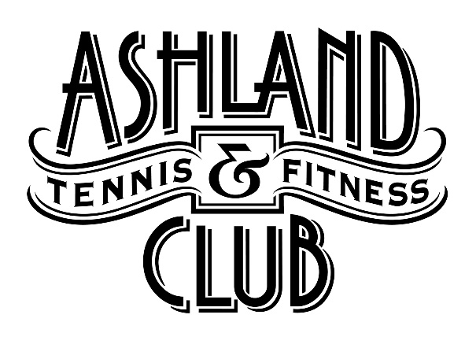

JUNIOR TENNIS
PROGRAM

January 6 – June 5, 2020

Ashland Tennis & Fitness Club
735 Jefferson Ave.
Ashland, OR 97520
Phone 541-482-4073
frontdesk.atfc@mind.net

CLASS DESCRIPTIONS
Specific instruction for individual styles will be the basis of these programs.

*Ages are approximate in class descriptions. Appropriate class will be decided by Director of Tennis.
RED BALL 1 (*ages 4-5) Instructor: Merilyn | Monday & Wednesday
This program is a fun introduction to tennis for our youngest players. Children will participate in a variety of skill building activities including basic athletic skills (running, jumping, throwing, bouncing, catching), tennis stroke technique and rally skills all in a fun environment. Kids will use appropriate balls, rackets and mini courts for size proportionate play. Good sport behaviors are introduced and reinforced. | 3:45 – 4:45 PM
$14 Member per class
$19 Non-Member per class

Max players per class: 6
RED BALL 2 (*ages 6-7) Instructor: Len | Monday & Wednesday
This program follows the red ball pathway system which uses age/skill appropriate equipment and court size so that young kids can learn and play the game quickly and develop proper skills. Curriculum is designed so that children will learn and practice all stroke fundamentals, court positioning, develop a serve, rally and begin point play. Good sport behaviors are introduced and reinforced. | 3:45 – 4:45 PM
$14 Member per class
$19 Non-Member per class

Max players per class: 6
ORANGE BALL (*ages 7-10) Instructor: Len | Tuesday & Thursday
This program follows the orange ball pathway system which uses age/skill appropriate equipment and court size so that young kids can learn and play the game quickly and develop proper skills. Kids will learn stroke technique, use of spin, combine shots together with purpose, serve with proper form, approach the net to use volleys and overheads and practice point play and scoring. Rules of play and good sport behaviors are introduced and reinforced. | 3:45 – 4:45 PM
$14 Member per class
$19 Non-Member per class

Max players per class: 16
GREEN BALL (*ages 11-18) Instructor: Len | Tuesday & Thursday
This program follows the green ball pathway system on a full court. Curriculum will vary based on experience and ability, with goals to develop or refine techniques to provide players with the tools to meet their goals. Emphasis will be placed on skills and application in live ball (point play) situations. Rules of play and good sport behaviors are introduced and reinforced. | 4:45 – 5:45 PM
$14 Member per class
$19 Non-Member per class

Max players per class: 24
INTERMEDIATE (*ages 11-18) Instructor: Len | Tuesday & Thursday
This program is using the regular ball. Players learn to rally with improved directions and height control, return serves and spins. A strong emphasis on stroke development, tactics and strategy in order to prepare the player for the USTA intermediate/low advanced and/or UTR tournaments. Private lessons are strongly encouraged. Good sport behaviors are reinforced. | 5:45 – 7:15
$21 Member per class
$26 Non-Member per class

Max players per class: 24
ADVANCED (*ages 11-18) Instructor: Len | Mon / Wed / Fri
This program is for committed, self-motivated players who are actively competing in Advanced USTA and/or UTR tournaments. High intensity drills will improve match play strategy, mental skill, footwork, shot selection, fitness and overall competitiveness. Players must be approved by Tennis Director and privates are strongly encouraged. Good sport behaviors are reinforced. | 4:45 – 6:15 PM
$21 Member per class
$26 Non-Member per class

Max players per class: 24

RESGISTRATION REQUESTED
by calling 541-482-4073.
Please register for the classes you plan to attend at least 24 hours in advance.

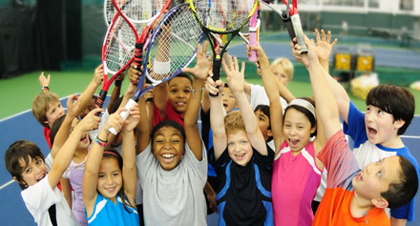

PRIVATE and GROUP LESSONS

Call the front desk to schedule private lessons.
If the staff can’t get you on the schedule, they
will have the Director of Tennis call you.

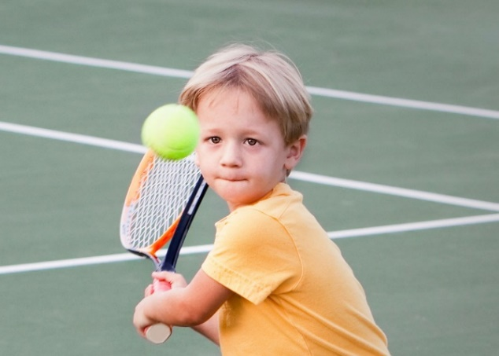
Individual & Group Private Lesson Rates
(non-member court fee included)
Cost: Member* Non-Member
1 Player $60 $68
2 Players $32 ea $40 ea
3 Players $23 ea $31 ea
4 & More $18 ea $26 ea
*plus $3 court fee for non-premium members
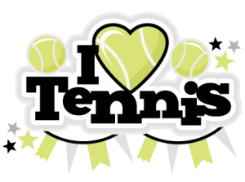

Please don’t hesitate to let us know if you have any questions or concerns about our program. We are here to help in any way we can.

